**EXERCISE 1: CONFIGURING A BASIC SPRING APPLICATION**

**PROGRAM**

**pom.xml**

<project xmlns="http://maven.apache.org/POM/4.0.0"

xmlns:xsi="http://www.w3.org/2001/XMLSchema-instance"

xsi:schemaLocation="http://maven.apache.org/POM/4.0.0

http://maven.apache.org/xsd/maven-4.0.0.xsd">

<modelVersion>4.0.0</modelVersion>

<groupId>com.library</groupId>

<artifactId>LibraryManagement</artifactId>

<version>1.0-SNAPSHOT</version>

<dependencies>

<!-- Spring Core -->

<dependency>

<groupId>org.springframework</groupId>

<artifactId>spring-context</artifactId>

<version>5.3.34</version>

</dependency>

</dependencies>

<build>

<plugins>

<!-- Plugin to run Java class using Maven -->

<plugin>

<groupId>org.codehaus.mojo</groupId>

<artifactId>exec-maven-plugin</artifactId>

<version>3.1.0</version>

<configuration>

<mainClass>com.library.MainApp</mainClass>

</configuration>

</plugin>

</plugins>

</build>

</project>

**applicationContext.xml**

<?xml version="1.0" encoding="UTF-8"?>

<beans xmlns="http://www.springframework.org/schema/beans"

xmlns:xsi="http://www.w3.org/2001/XMLSchema-instance"

xsi:schemaLocation="http://www.springframework.org/schema/beans

http://www.springframework.org/schema/beans/spring-beans.xsd">

<!-- Repository Bean -->

<bean id="bookRepository" class="com.library.repository.BookRepository" />

<!-- Service Bean -->

<bean id="bookService" class="com.library.service.BookService">

<property name="bookRepository" ref="bookRepository"/>

</bean>

</beans>

**BookRepository.java**

package com.library.repository;

public class BookRepository {

public void displayBooks() {

System.out.println("BookRepository: Fetching books from the database...");

}

}

**BookService.java**

package com.library.service;

import com.library.repository.BookRepository;

public class BookService {

private BookRepository bookRepository;

// Setter method for Spring to inject BookRepository

public void setBookRepository(BookRepository bookRepository) {

this.bookRepository = bookRepository;

}

public void listBooks() {

System.out.println("BookService: Listing books...");

bookRepository.displayBooks();

}

}

**MainApp.java**

package com.library;

import com.library.service.BookService;

import org.springframework.context.ApplicationContext;

import org.springframework.context.support.ClassPathXmlApplicationContext;

public class MainApp {

public static void main(String[] args) {

// Load Spring context from XML

ApplicationContext context = new ClassPathXmlApplicationContext("applicationContext.xml");

// Get BookService bean from context

BookService bookService = context.getBean("bookService", BookService.class);

// Call method to print the output

bookService.listBooks();

}

}

**OUTPUT**

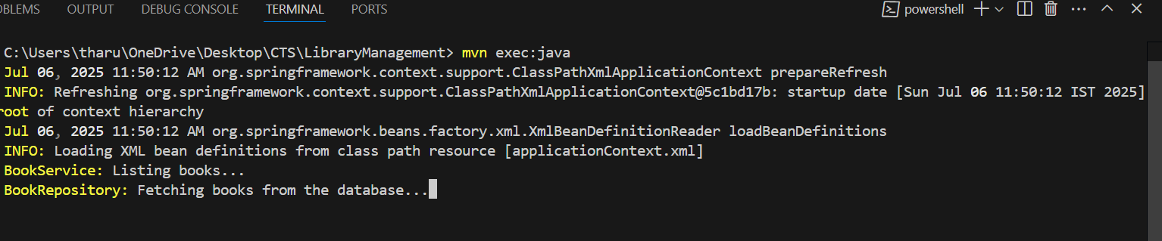

**EXERCISE 2: IMPLEMENTING DEPENDENCY INJECTION**

**Program**

**applicationContext.xml**

<?xml version="1.0" encoding="UTF-8"?>

<beans xmlns="http://www.springframework.org/schema/beans"

xmlns:xsi="http://www.w3.org/2001/XMLSchema-instance"

xsi:schemaLocation="http://www.springframework.org/schema/beans

http://www.springframework.org/schema/beans/spring-beans.xsd">

<!-- BookRepository Bean -->

<bean id="bookRepository" class="com.library.repository.BookRepository"/>

<!-- BookService Bean with Dependency Injection -->

<bean id="bookService" class="com.library.service.BookService">

<property name="bookRepository" ref="bookRepository"/>

</bean>

</beans>

**BookService.java**

package com.library.service;

import com.library.repository.BookRepository;

public class BookService {

private BookRepository bookRepository;

// Setter for Dependency Injection

public void setBookRepository(BookRepository bookRepository) {

this.bookRepository = bookRepository;

}

public void displayAllBooks() {

System.out.println("BookService: Requesting all books...");

bookRepository.getBooks();

}

}

**BookRepository.java**

package com.library.repository;

public class BookRepository {

public void getBooks() {

System.out.println("BookRepository: Fetching books from database...");

}

}

**LibraryManagementApplication.java**

package com.library;

import com.library.service.BookService;

import org.springframework.context.ApplicationContext;

import org.springframework.context.support.ClassPathXmlApplicationContext;

public class LibraryManagementApplication {

public static void main(String[] args) {

ApplicationContext context = new ClassPathXmlApplicationContext("applicationContext.xml");

BookService bookService = context.getBean("bookService", BookService.class);

bookService.displayAllBooks();

}

}

**OUTPUT**

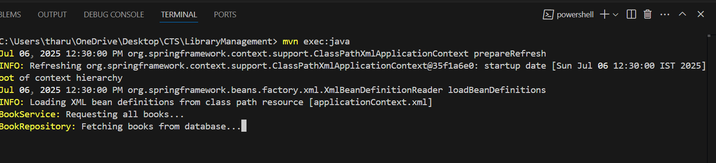

**EXERCISE 4: CREATING AND CONFIGURING A MAVEN PROJECT**

**pom.xml**

<project xmlns="http://maven.apache.org/POM/4.0.0"

xmlns:xsi="http://www.w3.org/2001/XMLSchema-instance"

xsi:schemaLocation="http://maven.apache.org/POM/4.0.0

http://maven.apache.org/xsd/maven-4.0.0.xsd">

<modelVersion>4.0.0</modelVersion>

<groupId>com.library</groupId>

<artifactId>LibraryManagement</artifactId>

<version>1.0-SNAPSHOT</version>

<dependencies>

<!-- Spring Context -->

<dependency>

<groupId>org.springframework</groupId>

<artifactId>spring-context</artifactId>

<version>5.3.34</version>

</dependency>

<!-- Spring AOP -->

<dependency>

<groupId>org.springframework</groupId>

<artifactId>spring-aop</artifactId>

<version>5.3.34</version>

</dependency>

<!-- Spring WebMVC -->

<dependency>

<groupId>org.springframework</groupId>

<artifactId>spring-webmvc</artifactId>

<version>5.3.34</version>

</dependency>

</dependencies>

<build>

<plugins>

<plugin>

<groupId>org.apache.maven.plugins</groupId>

<artifactId>maven-compiler-plugin</artifactId>

<version>3.8.1</version>

<configuration>

<source>1.8</source>

<target>1.8</target>

</configuration>

</plugin>

</plugins>

</build>

</project>

**OUTPUT**

